**An Implementation of Electronic Device User Profile Switching using Facial Detection**

Yash Gupta

Chandigarh University, Department of Computer Science and Engineering, Mohali, India yash733622@gmail.com

Kulvinder Singh

Chandigarh University, Department of Computer Science and Engineering, Mohali, India kulvinder.diet@gmail.com

Rahul Kumar

Chandigarh University, Department of Computer Science and Engineering, Mohali, India rir7890@gmail.com

**Abstract:** Facial detection technology is being explored for user authentication and access control. A system using facial detection and Siamese neural networks is proposed to manage multiple user profiles on a device. This secure and userfriendly system eliminates traditional authentication methods. The research outlines the system’s components and acknowledges operating system skills challenges. The potential benefits for organizations and users are highlighted. This research aims to contribute to advanced user authentication systems. User feedback and collaboration will drive continuous improvement.

**Index Terms**—Convolution, Face-detection, Authentication, Training/Testing

# I. INTRODUCTION

In our digital world, traditional authentication methods fall short. Enter facial detection technology—an innovative solution to user authentication and access control. By leveraging computer vision and AI, this tech recognizes users' unique facial features for swift, secure access. Our research aims to seamlessly integrate this technology for managing multiple user profiles on shared devices. We explore its potential to revolutionize digital interactions, prioritizing security and user experience. Join us as we delve into the methodology and implications, aiming to shape advanced and user-centric authentication systems for the future.

# II. BACKGROUND

In today's digital landscape, user authentication and access control are pivotal. Traditional methods like passwords and biometrics, while effective, have limitations. Managing multiple user profiles on shared devices presents challenges. Enter facial detection technology—fusing AI and computer vision—to revolutionize authentication. With front-facing cameras, it offers secure, seamless access. Our research delves into implementing this tech for managing multiple profiles on one device. By combining facial detection with Siamese neural networks, we aim to create a secure yet convenient solution. Join us as we explore its methodology, results, and broader impact, aiming to shape user-centric authentication systems for the digital era.

# III. OBJECTIVE

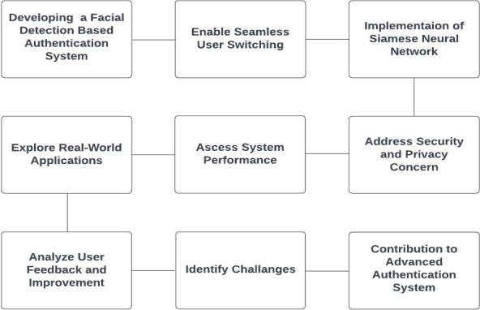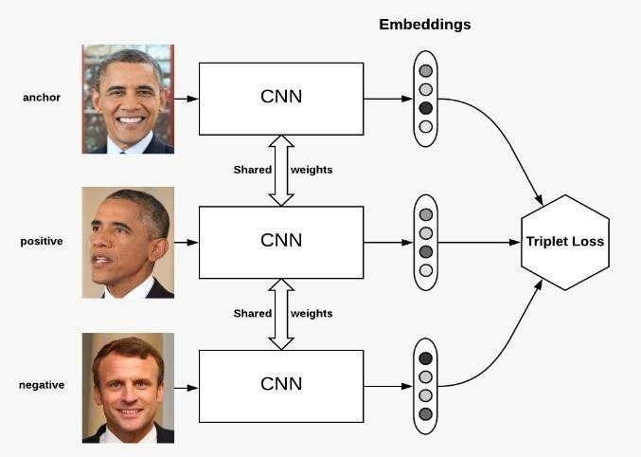

Figure 1 Objectives Figure 2 Base of Siamese Neural Network

**IV. SIGNIFICANCE**

This groundbreaking research on user authentication and access control introduces a facial detection-based system that holds the potential to revolutionize user interactions with electronic devices. The focal points of this innovative approach include not only enhancing user experience through seamless device access but also ensuring improved security by leveraging facial features for identity verification. The system's efficiency in shared environments is a notable highlight, simplifying access control in workplaces, educational institutions, and households, thereby boosting productivity and user satisfaction. The integration of Siamese neural networks adds a layer of sophistication, advancing authentication methods through deep learning and computer vision. Addressing compatibility challenges, the research also underscores cross-platform applicability, enabling the benefits of facial detection technology to extend across diverse devices and operating systems. Moreover, the research places a strong emphasis on privacy considerations, ensuring that the implementation of facial detection technology aligns with stringent privacy measures. By actively incorporating user feedback, the research embraces a user-centric approach, acknowledging the importance of real-world applications in personal devices, workplaces, and public facilities. Ultimately, this research contributes to shaping the future of user authentication, offering valuable insights and methodologies for creating advanced systems that cater to the evolving needs of individuals and organizations in our increasingly digital world.

**V. SCOPE**

The research described encompasses various key aspects related to facial detection-based authentication and its implications across different domains. Firstly, the primary objective is to explore and implement a facial detection-based authentication system, aiming to recognize and verify users based on their facial features. This system facilitates access to electronic devices and applications, and its detailed explanation is provided in the Siamese network paper. Additionally, the research includes the development of mechanisms that enable seamless user switching on shared devices, allowing multiple users to access personalized profiles without manual logins. The integration of Siamese neural networks is also a crucial component, aiming to enhance the accuracy of facial recognition through deep learning and computer vision capabilities. Furthermore, the scope extends to addressing security and privacy concerns associated with facial detection technology, safeguarding user data, and maintaining access control integrity. Rigorous testing and evaluation of the authentication system's performance are conducted, assessing accuracy, speed, and adaptability across different devices and operating systems. The paper also delves into the practical applications of facial detection technology, spanning personal devices, workplaces, educational institutions, and public facilities. It also identifies technical challenges and limitations, offering recommendations for overcoming them effectively. Moreover, the research aims to address compatibility challenges, enabling cross-platform applicability and contributing to the advancement of user authentication methods. Lastly, while the research represents a significant contribution, it acknowledges the dynamic nature of user authentication and allows for future directions and ongoing improvements in technology and methods.

# VI. LITERATURE REVIEW

User authentication and access control stand as integral elements in the realm of information security and digital user experiences. Over time, authentication methods have evolved from traditional options like passwords and PINs to the adoption of biometric measures such as fingerprint recognition. While these methods have been widely employed, they face challenges like security breaches and the complexity of remembering intricate passwords.[2]

Biometric authentication, encompassing fingerprint recognition and iris scanning, gained prominence for secure and user-friendly access control. However, it comes with limitations, including potential false positives and the need for specialized hardware. A notable advancement in this space is the rise of facial detection technology, offering a compelling alternative. This technology utilizes computer vision and deep learning to analyze unique facial features for recognition and verification.

Siamese neural networks integrated into facial detection systems have attracted attention for their excellence in creating feature embeddings, enabling accurate comparisons, even in diverse scenarios. Despite its promise, facial detection technology encounters challenges such as operating system compatibility, lighting conditions, and the risk of adversarial attacks.

Modern authentication methods prioritize the user experience, blending user convenience with robust security. Gathering user feedback for system enhancement has become a common practice. Looking ahead, the dynamic field of user authentication continues to witness advancements and innovations. Researchers and industry experts are actively exploring ways to enhance security, adaptability, and overall user satisfaction in authentication systems.

**VII. METHODOLOGY**

A. Data Collection

The research relied on a comprehensive dataset that encompassed various mobile phone specifications and their corresponding prices. This dataset was meticulously gathered from reputable online sources, ensuring data accuracy and completeness. It includes a wide array of features, such as RAM capacity, battery power, camera specifications, and other attributes pertinent to mobile phone models.[5] Facial detection using Siamese Neural Network- It’s based on super-vised learning machine learning model, where the data is passed in the form of keypair as input and output pair of data to the model. [3]

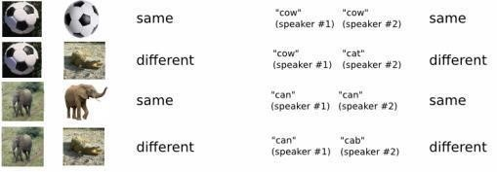

Figure 4 Simple representation of the supervised training model, passing key value pair

We will be creating 3 folders as represented in Figure 4: -

1. *Verification –* It stores the sample data of the authorized entities.
2. *Negative –* Stores negative data samples for supervised learning model. iii. *Realtime –* Storing the data of current entity trying to access into the system to verify with the data set of verification folder.

B. Data Preparation

The dataset underwent a thorough data cleaning and preprocessing regimen, addressing missing data through imputation or exclusion based on the degree of missingness. Feature selection techniques were meticulously applied to eliminate redundant or irrelevant features and enhance the efficiency of subsequent modeling. To ensure uniformity and mitigate undue attribute influence, data scaling techniques, such as Minmax scaling, were employed. Feature engineering played a pivotal role in crafting novel features and transforming existing ones to capture intricate relationships within the data, such as creating composite features like the ratio of RAM to battery power. The research evaluated three machine learning algorithms—K-Nearest Neighbors, Decision Tree, and Logistic Regression—selected for their classification suitability and compatibility with the dataset. The training-to-testing ratio was set at 70:30, and embedding layers, commonly used in NLP but explored for their relevance in computer vision, were considered. The datasets were thoughtfully partitioned for training and testing, employing cross-validation techniques to prevent overfitting. Evaluation metrics, including accuracy, precision, recall, and F1-score, were conscientiously employed to assess model performance, with a focus on face verification testing crucially explained in the Siamese network paper, adding depth to the evaluation process. [4]

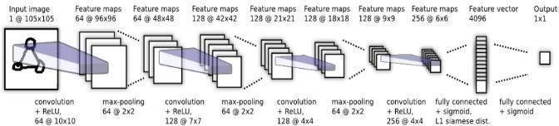

Figure 5 The core computation model of Siamese Neural Network

We will be applying the above represented model for both Verification image and Negative or Realtime image chosen at random from the data set of images.

1. *Ensemble Methods:* In addition to individual algorithms, the research explored ensemble methods, notably Random Forest, with the aim of enhancing model accuracy. Random forest, an ensemble of decision trees, was investigated to harness the collective predictive power of multiple models.
2. *Evaluation:* A meticulous comparison of models hinged on two key evaluation criteria: achieving the highest attainable accuracy and employing the minimal number of features. These metrics were pivotal in gauging both the predictive efficacy and computational efficiency of the models under consideration.

Under convolution we take a kernel and performing multiplication and addition operation, with ReLU activation then performing Pooling on the data matrix helping in down sampling of it.

After multiple iteration of convolution and pooling and creating a Feature map and applying flattening layer before passing it on to neural network for computation purpose.

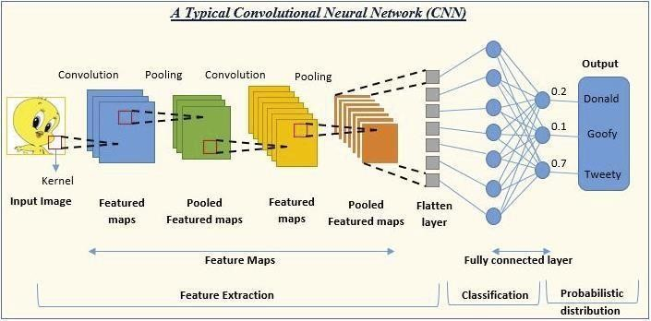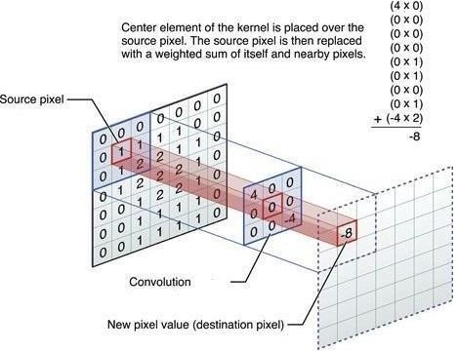

Figure 6 CNN Model Overview Figure 7 Convolution Operation on 7x7 matrix with 3x3 kernel classifying key points in the image

The ReLU activation function serves a crucial role in generating output from a given set of input values provided to a node or a layer. Its functionality is akin to that of a human neuron, where the node acts as a neuron receiving a collection of input signals. Based on these input signals, our brain processes information and determines whether the neuron should activate or remain inactive. Improving the result means to use the algorithms more efficiently so it can give more precise result during, research work. All this is used to improve the creditability of the paper and its data is fetch from the other research work. [10]

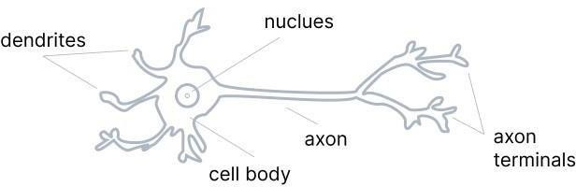 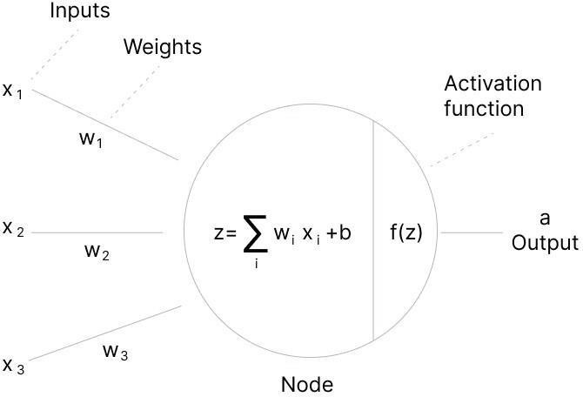

Figure 8 Neuron Representation Figure 9 Neuron Representation in Machine Model

In Siemens model we are using max-pooling kernel after creation of feature-map decreasing the complexity and dimensionality of the sample data size. Max-pooling gives the max value output from the kernel.

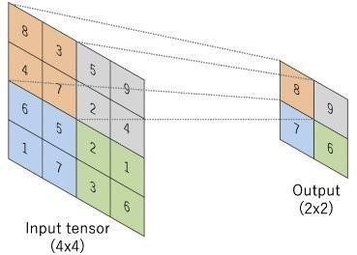 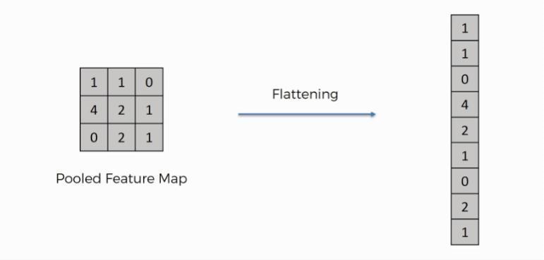

Figure 11-Dimensional Reduction Figure 10 Representation on Max-Pooling Kernal (Analytics Vidya)

Image → Convolution → Feature map → Pooling process → Pooled feature map → Flattening → One Dimensional Vector

Flattening is the process that convert Multidimensionality Pooled Feature map into One Dimensional Vector. This step is important because we want to insert the pooled feature map into Neural Network and Neural Network can take only One- Dimensional format of input.

**VIII. RESULTS AND ANALYSIS:**

The research findings were subject to comprehensive scrutiny. This encompassed an in-depth analysis of the experimental results, including accuracy scores, confusion matrices, and feature importance rankings. The primary focus was on identifying models that achieved the highest prediction accuracy while maintaining model simplicity and interpretability.

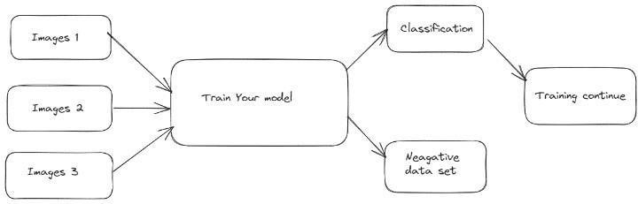 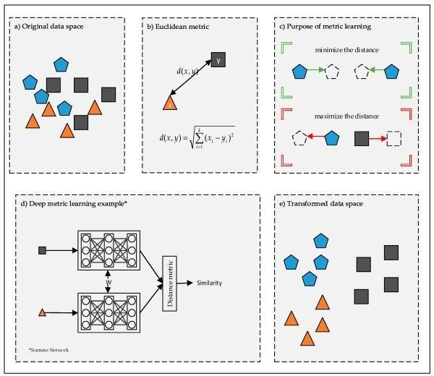

Figure 12 Model training steps Figure 14 Algorithm used to implement of model



Figure 13 Result obtained after Training

The CNN-based facial recognition approach displayed remarkable advancements in accurately detecting and verifying individuals. Utilizing the triplet loss during model training led to impressive accuracy, particularly in security, surveillance, and access control applications. However, real-world application requires further refinement to handle scalability and real-time processing challenges.

The Siamese neural network's incorporation proved robust, enhancing user detection accuracy by learning from both positive and negative datasets. Integrating diverse algorithms, including CNNs, k-Nearest Neighbors, decision trees, random forests, and K-means clustering, expanded the system's capabilities. Particularly, K-means clustering enables adaptability in undefined user profile situations, showcasing the approach's flexibility. This comprehensive blend of cutting-edge technologies positions the system as a versatile tool for user authentication and identification across various industries.[1]

# X. COMPARISON STUDY

A. *Convolution:*

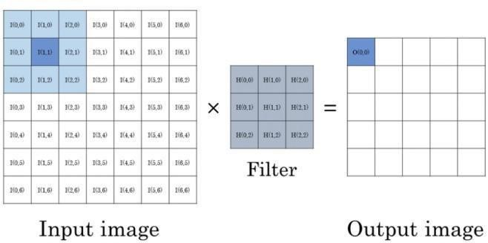 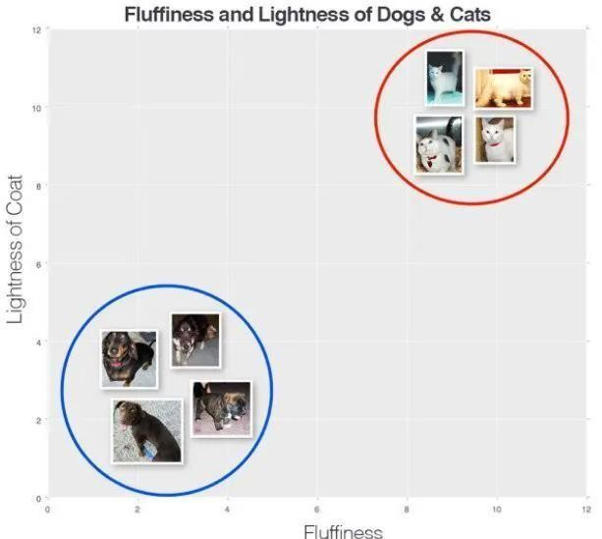

Figure 15 How convolution works Figure 16 K-Nearest Neighbor

Convolution is an image processing technique employed in this research, aimed at transforming images by applying a kernel over each pixel and its neighboring pixels. This kernel, represented as a matrix of specific values, dictates how the convolution process alters the image. [8]

In convolution, a series of key steps are involved:

i The mask is flipped only once both horizontally and vertically.

ii The mask is systematically moved across the image.

iii The corresponding elements of the mask and image are multiplied, and the results are added to create a smaller-sized matrix. iv This process is repeated until all the image values have been processed.

Convolution plays a crucial role in image and speech recognition. It is a key element in Convolutional Neural Networks (CNNs), which are extensively used in these tasks.

Siamese networks are used for image authentication. They employ diverse learning strategies, including a loss function that considers batch size and index. The objective is to balance classification accuracy with a regularization term to prevent overfitting. Here's the equation for the loss function:

L(x1(i), x2(i)) = y(x1(i), x2(i)) log p(x1(i), x2(i)) + (1 - y(x1(i), x2(i))) log (1 - p(x1(i), x2(i))) + λT |w|²

where:

M is the batch size,i is the index, y(x1(i), x2(i)) is the label based on whether x1 and x2 belong to the same character class, p is the probability, λ is a regularization parameter, w denotes model parameters.

This equation takes into account both the classification accuracy and the complexity of the model to prevent overfitting.

K-Nearest Neighbors (KNN) is a straightforward and effective image classification algorithm that relies on analyzing the distance between feature vectors. It is akin to building an image search engine.

In this example, we can observe two distinct categories of images, with data points in each category clustered closely together in an n-dimensional space. Dogs, for instance, tend to have dark coats that are not very fluffy, while cats have light coats that are extremely fluffy.

 

Equation 1 Euclidean Distance Equation 2 Manhattan Distance

This suggests that the distance between two data points within the red circle is much smaller than the distance between a data point in the red circle and a data point in the blue circle. [7]

To apply k-Nearest Neighbor classification, we must establish a distance metric or similarity function. Common choices include the Euclidean distance and the Manhattan (city block) distance. Depending on the nature of your data, other distance metrics or similarity functions may be used. For simplicity, in this blog post, we will utilize the Euclidean distance to measure image similarity.

Facial Detection and Convolution: The convolution method is pivotal in extracting crucial features from facial images. It sifts through images using a kernel to capture essential facial attributes, aiding in validation and image matching. This method, integral to image and speech recognition via CNNs, excels in identifying patterns in facial data, ensuring stable and consistent behavior within a linear time-invariant system.

Contrastingly, the decision tree method diverges in its approach. Represented by branching structures, decision trees are tailored for decision-making processes across domains. They don't engage in image processing but instead navigate branching decisions to ascertain outcomes, notably in business planning and data classification tasks.

The references to classifier methods are derived from Siamese network research, fortifying the model's accuracy and predictability. These algorithms enhance the Siamese network's functionality, adding layers of accuracy and predictability to the model.

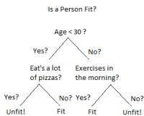 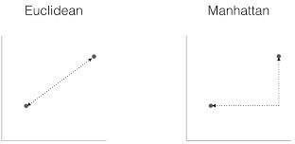

Figure 18 Decision tree Figure 17 Euclidean and Manhattan Distance

*Comparison and Distinctiveness:*

The convolution and decision tree methods diverge significantly in their purposes. Convolution is integral for image processing, feature extraction, and pattern identification, particularly in facial recognition and matching. Conversely, decision trees are tools for data classification and decision-making, focusing on categorizing input data.[6]

Convolution prioritizes feature extraction from facial images, while decision trees concentrate on decision-making based on input data. Convolution operates within a linear time invariant system, essential for image and speech recognition. On the other hand, decision trees are unrelated to image processing and don't involve linear systems.

B. Activation Functions:

“A neural network without an activation function is essentially just a linear regression model.”

Activation functions in Siamese networks are employed to introduce non-linearity into the model and facilitate the network in capturing intricate patterns and relationships within the data. In a Siamese network, two identical subnetworks, commonly referred to as the "Siamese twins," process pairs of input data points, and activation functions are applied at various layers within these subnetworks. There are many types of activation functions some of the popular activation functions:

1. *Binary Step Function*:

This activation function is based on a simple model basing on a threshold value, if the value is above limit, then activate the neural network or else if not then no activation of the neural network.

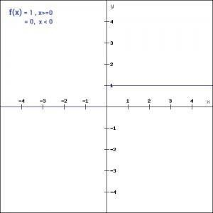 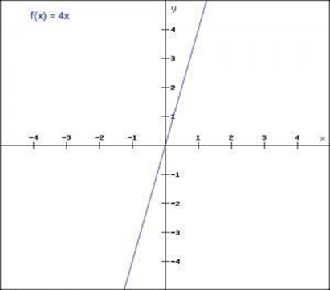 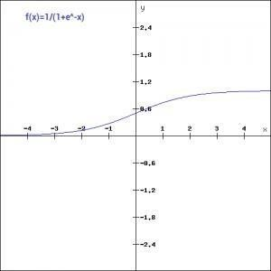

Figure 19 Binary Activation Function Figure21 Sigmoid Activation Function Figure20 Linear Activation Function

It has some caveats like due to its no differentiability, binary step function leads to vanishing gradient problem.

Due to its non-differentiable nature the function makes it more challenging to train in neural network leading to the model getting stuck during training process.

1. *Linear Function*:

In liner function it defines a straight-line relationship with input and output variables. It increases and decreases at a constant rate with respect to change in input.

  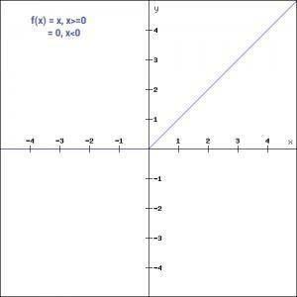 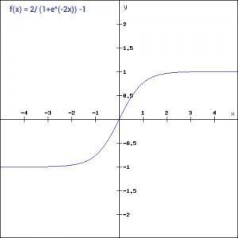

Figure21 Sigmoid Activation Function Figure20 Linear Activation Function Figure 22 Tanh Activation Function Figure 23 ReLU Activation Function

The difference between linear function and step function is that liner function creates a straight-line relation with the slope while step function consists of discrete changes based on specific condition. [12]

In the realm of neural networks and deep learning, activation functions play a crucial role in shaping the output of neurons. Among these functions, the Sigmoid activation function is notable for transforming values into the range of 0 to 1, offering nonlinearity to the network. Tanh, a variant of the Sigmoid function, extends its range to -1 to 1 while maintaining symmetry around the origin. Both Sigmoid and Tanh exhibit continuity and differentiability. Another influential player is the Rectified Linear Unit (ReLU), a nonlinear activation function widely embraced in artificial and deep learning. A key advantage of ReLU is its selective activation, ensuring neurons are only deactivated when the linear transformation output is below 0. An updated form of ReLU addresses issues where it would represent 0 even for negative inputs. Shifting focus to classifier algorithms in the context of Siamese networks, these algorithms operate post-processing by assigning labels or similarity scores based on learned representations. Common classifiers include Euclidean Distance, which considers data points similar if their distance is below a threshold, and Cosine Similarity Calculation, where a higher cosine similarity indicates greater similarity. Triplet Loss Calculation is a specialized loss function used in training Siamese networks, promoting the minimization of distances between similar pairs and the maximization of distances between dissimilar pairs. Notably, in certain scenarios, the Siamese network itself can function as a classifier by incorporating classification layers after its Siamese twins, allowing it to make final classification decisions based on learned representations.

**XI. CONCLUSION**

research introduces an innovative approach to user authentication and access control, combining Siamese neural networks and facial detection. Imagine effortlessly managing multiple user profiles on a shared device – that's the capability of this groundbreaking system! The key features include front-camera facial detection for secure and convenient access, Siamese neural networks offering precise user identification, training the system with negative and positive data files to distinguish authorized users, and real-time image capture for continuous monitoring and heightened security. The benefits encompass the elimination of traditional methods like passwords and fingerprints, an enhanced user experience with fast, secure, and hands-free access, improved security with robust protection against unauthorized access, and adaptability across various personal and business environments. Looking to the future, the focus is on continuous improvement through user feedback and collaboration, ensuring regulatory compliance with data privacy regulations. Beyond conventional face unlocking, this research integrates Siamese networks, allowing the system to adeptly handle multiple user profiles on a single device, making it ideal for shared computing environments. Visual enhancements include images depicting facial recognition unlocking, simple diagrams illustrating Siamese networks, and icons representing different user profiles on a shared device.[13]

References:

1. Siamese Neural Network for One-shot Image Recognition by Gregory Koch GKOCH@CS.TORONTO.EDU Richard Zemel ZEMEL@CS.TORONTO.EDU Ruslan Salakhutdinov RSALAKHU@CS.TORONTO.EDU
2. Bengio, Yoshua. Learning deep architectures for ai. Foundations and Trends in Machine Learning, 2(1):1–127, 2009.
3. Bromley, Jane, Bentz, James W, Bottou, Leon, Guyon, ´ Isabelle, LeCun, Yann, Moore, Cliff, Sackinger, Ed- ¨ uard, and Shah, Roopak. Signature verification using a siamese time delay neural network. International Journal of Pattern Recognition and

Artificial Intelligence, 7 (04):669–688, 1993.

1. Chopra, Sumit, Hadsell, Raia, and LeCun, Yann. Learning a similarity metric discriminatively, with application to face verification. In Computer Vision and Pattern Recognition, 2005. CVPR 2005. IEEE Computer Society Conference on, volume 1, pp. 539– 546. IEEE, 2005.
2. Proceedings. Ninth IEEE International Conference on, pp. 1134– 1141. IEEE, 2003. Fei-Fei, Li, Fergus, Robert, and Perona, Pietro. One-shot learning of object categories. Pattern Analysis and Machine Intelligence, IEEE Transactions on, 28(4):594– 611, 2006.
3. Hinton, Geoffrey, Osindero, Simon, and Teh, Yee◻Whye. A fast learning algorithm for deep belief nets. Neural computation, 18(7):1527–1554, 2006.
4. Krizhevsky, Alex, Sutskever, Ilya, and Hinton, Geoffrey E. Imagenet classification with deep convolutional neural networks. In Advances in neural information processing systems, pp. 1097–1105, 2012.
5. Lake, Brenden M, Salakhutdinov, Ruslan R, and Tenenbaum, Josh. One-shot learning by inverting a compositional causal process. In Advances in neural information processing systems, pp. 2526–2534, 2013. Lake, Brenden M, Lee, Chia-ying, Glass, James R, and Tenenbaum, Joshua B. One-shot learning of generative speech concepts. Cognitive Science Society, 2014.
6. Palatucci, Mark, Pomerleau, Dean, Hinton, Geoffrey E, and Mitchell, Tom M. Zero-shot learning with semantic output codes. In Advances in neural information processing systems, pp. 1410–1418, 2009.
7. Simonyan, Karen and Zisserman, Andrew. Very deep convolutional networks for large-scale image recognition. arXiv preprint arXiv:1409.1556, 2014.
8. Taigman, Yaniv, Yang, Ming, Ranzato, Marc’Aurelio, and Wolf, Lior. Deepface: Closing the gap to human-level performance in face verification. In Computer Vision and Pattern Recognition (CVPR), 2014 IEEE Conference on, pp. 1701–1708. IEEE, 2014.
9. Wu, Di, Zhu, Fan, and Shao, Ling. One shot learning gesture recognition from rgbd images. In Computer Vision and Pattern Recognition Workshops (CVPRW), 2012 IEEE Computer Society Conference on, pp. 7–12. IEEE, 2012.
10. Analitic Vidya Fundamentals of Deep Learning, Activation Function Dishasree26 Gupta Aug,2023.
11. Mohd. Sadiq, Aleem Ali, Syed Uvaid Ullah, Shadab Khan, and Qamar Alam, "Prediction of Software Project Effort Using Linear Regression Model," International Journal of Information and Electronics Engineering vol. 3, no. 3, pp. 262-265, 2013.